

APPLICATION DEVELOPMENT THEORY4
GROUP 1 EXERCISE
Due: 04/08/2026
Name and Surname: | Student Number:
Phindile Lisa Ngozi | 230640893
Olwethu Nene | 230277845
Zenande Kalipa | 230012035
Yanga Jilaji | 222582731
Mziwamangwevu Ntutu | 217054420
Thabiso Matsaba | 220296006
Thandolwethu Siloyi | 216112303

Figure 1: UML State Machine Diagram
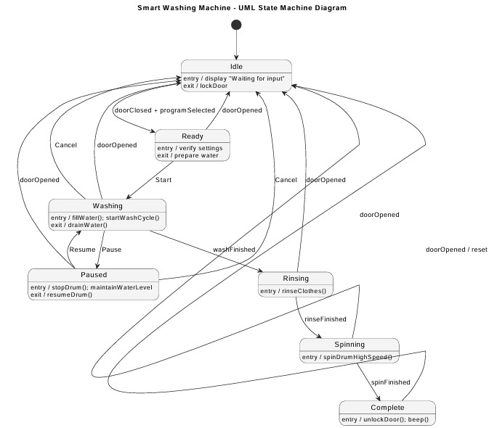

Explanation of the UML State Machine Diagram
A UML State Machine Diagram is used to display how an object or system (such as a smart washing machine) transitions through various states during the washing process. The smart washing machine starts in the Idle State, waiting for user input, and displays a message indicating it is ready to use. When the user closes the door and selects a washing machine program, the smart washing machine enters the Ready State. In the Ready State, the washing machine verifies the settings and fills the drum with water to prepare for washing. After the Start button has been pressed by the user, the smart washing machine advances to the Washing State, where it begins to fill the drum with water and commences the washing process.
Users are allowed to either stop/ or resume using their washing machines at any point in time by putting their machines into either a Paused or Idle state, respectively. Once the user has completed their wash cycle, the machine will automatically progress through the Rinsing State, then through the Spinning State, where all excess water is removed. Once all excess water has been removed from the clothes, the machine will enter the Complete State, where upon the door will unlock and will produce an audible signal indicating that the wash cycle has been completed. The machine will revert to Idle State whenever the door is opened during an active wash cycle. This is done for safety reasons.

Figure 2: UML Sequence Diagram
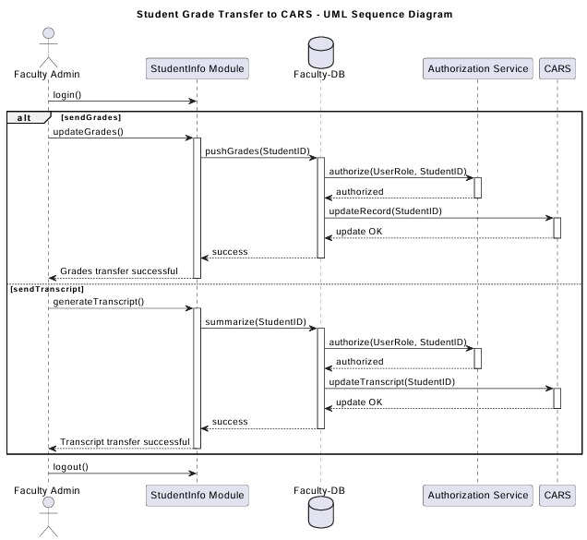

Explanation of the UML Sequence Diagram
The UML Sequence Diagram depicts the interaction of the various components of the University’s system in relation to sending student data to the Central Academic Records System (CARS). When the Faculty Admin logs into the system, they use the StudentInfo Module (this Module manages all student data at the Faculty level).
The sequence diagram has an alt fragment that shows two possibilities: sendGrades and sendTranscript. When the Faculty Admin initiates the sendGrades process by requesting a transfer of grades, this action triggers the StudentInfo Module’s ability to perform the updateGrades() operation. Once the grades are stored in the Faculty Database, the Authorization Service verifies the Faculty Admin’s ability to access these records. Upon approval, the updated grade will be submitted to CARS using the updateRecord (StudentID) operation, and a confirmation of the transfer will be provided to the Faculty Admin.
For the sendTranscript process, the Faculty Admin requests a Transcript Summary. With the data from the Faculty Database, the StudentInfo Module will create the Transcript and authorize the Faculty Admin’s access to this record. The Transcript will then be sent to CARS using the updateTranscript (StudentID) operation. When the Transcript has been successfully sent, the Faculty Admin will receive confirmation of the transfer, and the process will conclude when the Faculty Admin logs out.

